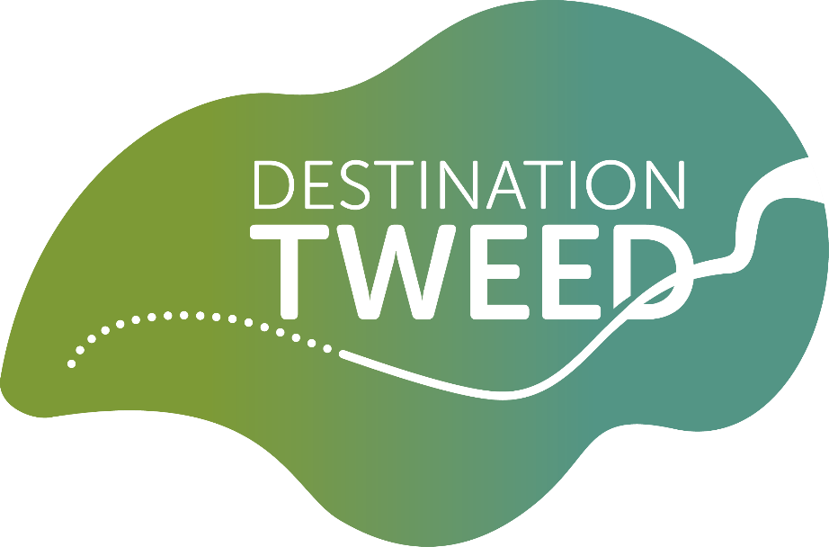

Community Grants Scheme
Application Form

Please refer to the guidance notes while completing this form, available at:
destinationtweed.org/project/community-grants

Please also refer to the map provided alongside the application form and guidance notes to confirm that your project takes place within the specified geographic area.

A printable version of this form, to be completed manually, is available on request. Please ask for a copy by emailing info@destinationtweed.org.

Key Information

Who can I contact for advice?

Please contact info@destinationtweed.org for guidance and advice on the application process. We advise you to discuss your project with the team in advance of applying, to ensure that your project is eligible.

How much can I apply for?

Our minimum grant amount is £1000 and our maximum is £10,000. You can potentially apply more than once, with no less than 12 months between applications, however this is dependent on available funds, so should not be relied upon. Any previous projects funded by this Community Grants Scheme must be completed before you apply again. Our grant should represent at least 10% of your project costs.

What is Destination Tweed?

Destination Tweed (DT) offers a distinctive and transformational opportunity for communities and those visiting a combined area of the Scottish Borders, Northumberland and Dumfries and Galloway. Destination Tweed is comprised of a collection of thirteen projects that will deliver significant economic, environmental, educational, community, climate, health and social benefits. The largest of the projects, the River Tweed Trail, will connect the diverse communities and numerous attractions and assets along the full length of the River Tweed as a new long-distance source to sea path which roughly follows the River Tweed from high in the hills above Moffat, to where it flows into the North Sea at Berwick-upon-Tweed.

Destination Tweed will celebrate and share the nature, history and stories of the River Tweed, one of the UK’s most highly designated and inspirational river corridors. A five-year, partnership-led investment beginning in 2022 will deliver a source to sea trail, which respects its special status and connects communities and attractions with sensitive, impactful and innovative interpretation. The landscape and river habitats will be enhanced and better understood, new and existing audiences will be meaningfully and actively engaged, and we will create opportunities to celebrate, care for, enjoy and promote the river sustainably whilst achieving health, wellbeing and economic development ambitions.
Destination Tweed Vision Statement, July 2023

You can read about Destination Tweed in more detail here: destinationtweed.org/about

What is the aim of the Community Grants Scheme?

Grants are available to projects with a connection to the River Tweed and its Nature, History and Stories. These are the Themes of the DT Community Grants Scheme.

The aim of the DT Community Grants Scheme is to support local groups and organisations in delivering projects/activities that make the Tweed Catchment a great place to live, work and visit.

Our grant Outcomes:
- The nature and biodiversity of the River Tweed* and its environs will be enhanced , better understood, enjoyed and/or promoted;
- More people, and a wider range of people, will have had increased access to the outdoors and opportunities to engage with the River Tweed* and its environs;
- The history and prehistory of the River Tweed* and its environs and communities will be better understood by a wider range of people, and the area’s historic sites and monuments will be in a better condition and/or better maintained;
- The stories, culture and traditions of the River Tweed* and its environs and communities will be highlighted, preserved and/or shared.
*For projects within the eligible areas from Moffat northwards, and from Biggar eastwards along the Biggar Water, projects should align with the themes and outcomes as applicable to the local area, i.e. without requirement for specific links to the River Tweed.
You must demonstrate that support from DT Community Grants Scheme will deliver activities that support at least one of our grant Outcomes, while aligning with at least one of our Themes of Nature, History and Stories. Projects are not expected to meet all Outcomes, and applications for projects with a strong, clear focus on one or two Outcomes are more likely to be assessed favourably than projects that meet all four Outcomes only loosely.
What are the deadlines for submission of completed applications?

Please see information online for up-to-date application deadlines:
destinationtweed.org/project/community-grants/

Who can apply?

We welcome applications from:

- Charities
- Constituted community and/or voluntary groups and societies
- School-based projects via parent-teacher councils, pupil councils, school trusts etc.
- Not-for-profit organisations
- Social enterprises
- Community interest companies

Applications from individuals/businesses will only be considered under exceptional circumstances and must strongly demonstrate that public benefit outweighs any private gain.
Projects must be based entirely or predominantly within 2km of the River Tweed (or within 2km of links to Biggar and Moffat). To check whether your project falls within the boundary, please see the map at provided alongside the application form and guidance notes.
If you are uncertain whether your project will be eligible, please get in touch with the team to discuss: info@destinationtweed.org.

about you and your organisation

- Title:
- First name:
- Last name:
- Name of organisation:
- Your role/job title:
- Main contact’s correspondence address:
- Organisation address (if different from above):
- Phone:
- Email:
- Website if applicable:
- Social media handles if applicable:
- Which of these categories best describes your organisation?
- Charity
Please provide your charity number if applicable:
- Constituted community and/or voluntary group or society
- Parent-teacher council, pupil council, school trust etc.
Please give details:
- Not-for-profit organisation
- Social enterprise
- Community interest company
- Other: please give details:

- Is your organisation based within, or does it operate within, 2km of the River Tweed (or 2km of links to Biggar or Moffat)? You can check on the map available alongside the application form and guidance documents.
Yes
No

- Please tell us about the kinds of activities or services that your organisation provides (no more than 300 words):

- If your organisation is VAT registered, please provide your VAT registration number:

- Bank account name:
Account number:
Sort code:

- Please provide the following information from your most recent accounts:
Total income | Total surplus/deficit | Current unrestricted reserves

- Why aren’t you using your reserves to pay for this project? (no more than 150 words)

about your project

- Project title:

- Will your project/activities take place within 2km of the River Tweed (or within 2km of links to Biggar or Moffat)? Please see the map available alongside the application form and guidance notes if you are unsure whether your project is within the relevant area.
Yes
No

- Have you previously discussed your project with a member of the Destination Tweed team?
Yes
No

- If you answered yes at 2c, please let us know who you’ve discussed your project with:

- Describe your project and its objectives in 300 words or less:

- Please specify which one of the Community Grants Scheme’s Themes of Nature, History and/or Stories you feel your project aligns with most closely (please select only one):

Nature
History
Stories

- Please outline how your project aligns with at least one of our specified Outcomes. Please see guidance notes in reference to alignment with multiple grant Outcomes. Please focus on the outcome(s) that is (are) most relevant to your project (max. 200 words per selected outcome, but no more than 500 words in total):

Our grant Outcomes:
The nature and biodiversity of the River Tweed and its environs will be enhanced, better understood, enjoyed and/or promoted

More people, and a wider range of people, will have had increased access to the outdoors and opportunities to engage with the River Tweed and its environs

The history and prehistory of the River Tweed and its environs and communities will be better understood by a wider range of people, and the area’s historic sites and monuments will be in a better condition and/or better maintained

The stories, culture and traditions of the River Tweed and its environs and communities will be highlighted, preserved and/or shared

- How do you know that there is a need or demand for your project (200 words or less)?

- Who will benefit from your project, and in what ways will they benefit? (200 words or less).

- How will you promote and publicise your project/activities? (100 words or less).

- Project timetable (you may attach this separately – please state below):

- Please state your project’s key outputs (direct results e.g. number of events, activities, capital works) (200 words or less)

- How will you measure the success of your project? (100 words or less)

- How will you manage your project? (150 words or less)

- Please give details of any volunteer time that you anticipate will contribute to the management of the project, e.g. time spent planning and delivering project activities by volunteers. Please specify what types of activities you anticipate volunteers carrying out, and how much time you expect them to contribute in total throughout the project (100 words or less).

- How do you plan to maintain any of the project’s assets beyond the lifetime of the grant? (100 words or less)

- Does your project involve capital works to a location, building, archaeological site/monument or other?

Yes
No If no please go to 2v

- Please provide the exact location of the building/site using either an address and postcode (for buildings that can be easily located through a postal address), a grid reference or what3words location.

- Does your organisation own the location, building, archaeological site/monument or other?

Yes If yes, please go to 2u
No If no, please go to 2t

- Have you sought permission from the person/organisation that owns the site/building/location?

Yes
No

- If you answered yes at question 2t, please provide evidence of consent (see Section 5, Supporting Documents as appropriate), or include below a statement on progress towards securing consents necessary to undertake your project. If you answered no, please note that we are unlikely to approve applications from projects where relevant permissions are not in progress or already in place. (100 words or less)

- Does your project require planning permission or any other regulatory compliance/consent such as Scheduled Monument Consent, Listed Building Consent, SSSI Consent before it can go ahead?

Yes
No If no, please go to 2x

- Please state whether you have begun the application and/or what progress you have made. Please note that we are unlikely to support applications from projects where relevant permissions are not in progress or already in place. (100 words or less)

- What will happen if your project does not receive a grant from us? (100 words or less)

project COSTS

- Please include details of all direct project costs (these can be broken down by budget heading rather than an itemised list e.g. equipment, professional fees, venue hire etc.). For projects in which we would be one of a number of funders, please provide the total project costs, not just the part that you would like us to fund.

Item | Cost | VAT if applicable | Total cost
TOTAL

- How do you know that these costs are accurate? Please provide details below of any quotes or advice that you have received to help you put together your project costs. (100 words or less)

- How much are you seeking from the Destination Tweed Community Grants Scheme? Bear in mind that our grants range from £1000 to £10,000, and that the amount that you request from us must represent at least 10% of your total project costs. We can also support projects to a 100% level.

- Please include details of any match funding if available
Funder | Status (Pending/Confirmed) | Amount | Date of decision, if pending
TOTAL

- Will your organisation earn money through this project?
Yes
No

- If you answered yes to 3e, please give brief details (100 words or less)

DECLARATION

By signing here, you are confirming that all the information submitted in this form is accurate at the time of submission, and that you have the authority to submit this application on behalf of your organisation. You also confirm that you will let us know at the earliest opportunity of any significant alterations to your project, or if the project cannot proceed.

Name:
Position within organisation:
Signature:
Date:

DATA PROTECTION: we will use the information contained within this form to assess your application and administrate any grant we may award you. This information may be used to analyse our own grant-making and for our own research purposes. We may also circulate this information to other parties for the purposes stated above.

SUPPORTING DOCUMENTS

You must provide the following:
- Most recent annual accounts (signed)

Please provide the following as appropriate:
- A copy of your organisation’s constitution, if applicable
- Plans and specifications for any capital works to be undertaken
- Maps, plans, photos
- Business plan
- Annual report
- Copies of quotes or tender documents
- Copies of leases, deeds or other proof of ownership
- Letters of landowner consent
- Letters of support for your project (no more than four)
- Evidence of any required permissions
- Other (please state)

Please return completed forms, with supporting documents as attachments, to: info@destinationtweed.org. Application deadlines are advertised online at: destinationtweed.org/project/community-grants/

Please let us know how you heard about Destination Tweed’s Community Grants Scheme

What happens next?
We aim to notify you of our decision within 6 weeks of the application deadline.

