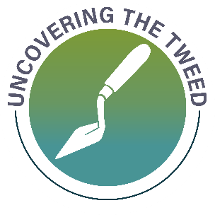
UNCOVERING THE TWEED – CROSSING THE TWEED
Fill in the boxes below with any information you can gather about bridges, fords, ferries or other crossing points located on or around the River Tweed. You can email this to Geoff at geoff.parkhouse@aocarchaeology.com, or save it in the project data folder, at this link.
The Study ID is the number generated by the interactive web map, when you create a new point (Study ID in the pop-up window that appears when you click on a point).
Link to Web Map Here
STUDY ID | Notes | Sources

